Homework 3

Jiaqi Li

1.

> treatment.not.random = c(rep("1",10),rep("2",10),rep("3",10))

> treatment=sample(treatment.not.random)

> n=length(treatment)

> exp.unit=1:n

> mu=4.7

> tau.1=-3

> tau.2=5

> tau.3=-2

> va=4

>

> means=rep(NA,n)

> means[treatment=="1"]=mu+tau.1

> means[treatment=="2"]=mu+tau.2

> means[treatment=="3"]=mu+tau.3

>

> y.sim=means+rnorm(n,mean=0, sd=sqrt(va))

> Simdata=data.frame(exp.unit,treatment,y.sim)

> head(Simdata)

exp.unit treatment y.sim

1 1 2 9.213822

2 2 3 2.491847

3 3 3 3.529146

4 4 1 1.979061

5 5 2 10.723467

6 6 1 4.779404

>

> boxplot(y.sim~treatment, main="Boxplot of Simulated ANOVA Data")

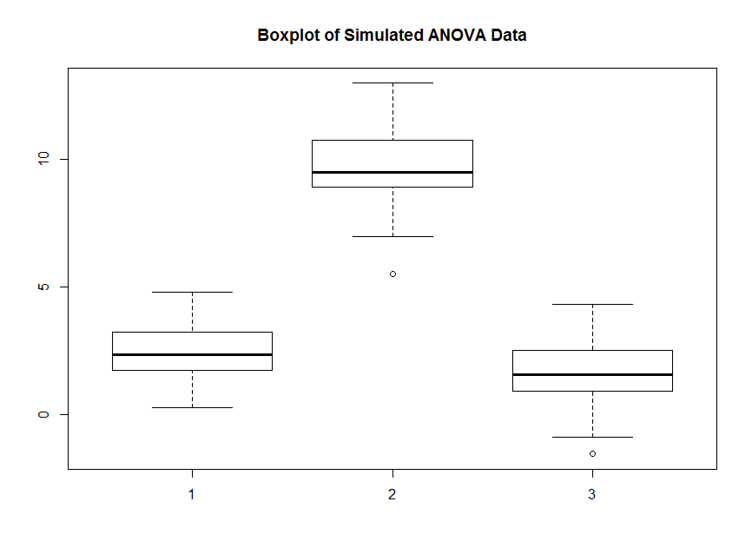

2.

> means.reduced=rep(mu,n)

> y.sim.reduced=means.reduced+rnorm(n,mean=0,sd=sqrt(va))

> Simdata.reduced=data.frame(exp.unit,treatment,y.sim.reduced)

> head(Simdata.reduced)

exp.unit treatment y.sim.reduced

1 1 2 7.700076

2 2 3 2.440189

3 3 3 2.223211

4 4 1 3.865510

5 5 2 7.012322

6 6 1 4.467421

>

> boxplot(y.sim.reduced~treatment, main="Boxplot of Simulated ANOVA Data With Reduced Model")

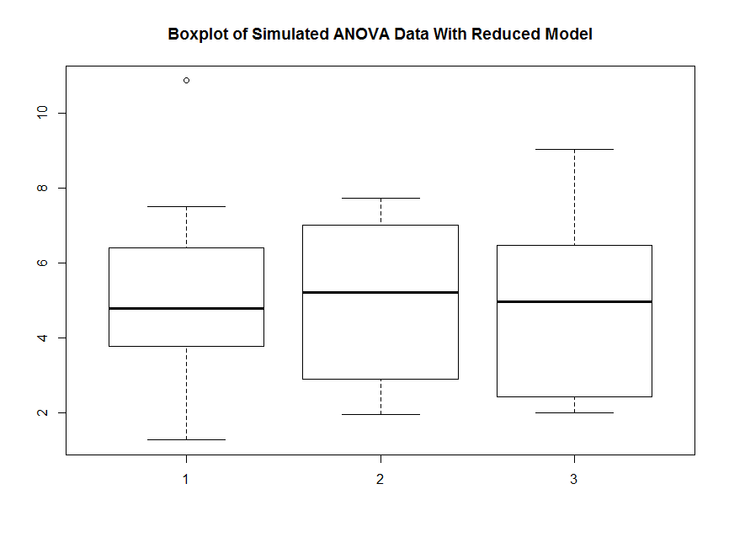

With τ1 = τ2 = τ3 = 0, there is not much noticeable difference in the boxplots of response values from the three treatments while the mean and variance of each treatment are the same.

Also, compared to the boxplots of problem 1, medians of each treatment in problem 1 are quite different while medians of boxplots of problem 2 are very close to each other.

3.

> va.3=50000*va

> y.sim.3=means+rnorm(n,mean=0, sd=sqrt(va.3))

> boxplot(y.sim.3~treatment, main="Boxplot of Simulated ANOVA Data With Increased Variance")

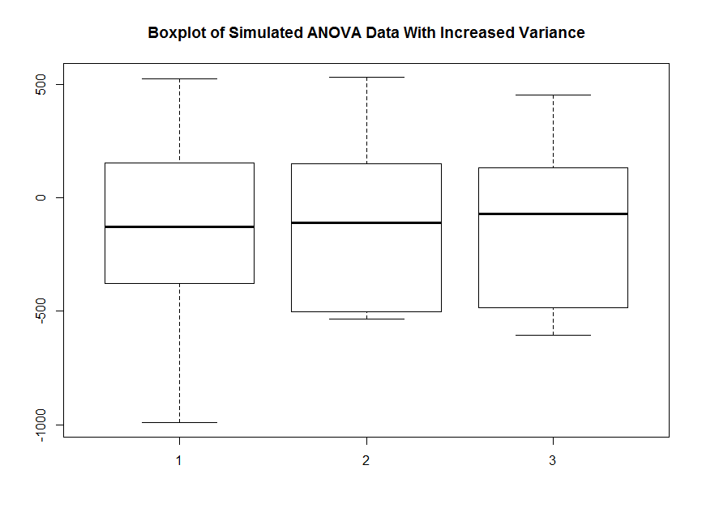

Here, the value of σ^2 is multiplied by 50000, and there is no noticeable difference in the boxplots of response values from the three treatments.

4.

Under the model in Problem 1, **the distribution of Y23 is Normal** because ϵ23 is normal and μ + τ2 is a number.

By the definition of a + N(0,σ^2) = N(a,σ^2),

Y23 ∼ N(9.7, 4) where μ + τ2 = 9.7, σ^2 = 4

5.

Under the model in Problem 1, **the distribution of Y2._bar is Normal** because:

∑Y2t ∼ N(9.7 × 10,10 × σ^2) = N(97,10σ^2)

(∑Y2t) / r2 ∼ (1/10) × N(97,10σ^2) ∼ N(9.7,0.1 × 4) = N(9.7,0.4)

Thus, Y2._bar is Normal distributed.

6.

Under the model in Problem 1, **the distribution of the difference between an experimental unit receiving treatment 1 and an experimental unit receiving treatment 2 is normal distribution**. Because:

Y1t ∼ N(4.7 - 3, 4) = N(1.7, 4), t ∈ {1, 2, …, 10}

Y2t ∼ N(4.7 + 5, 4) = N(9.7, 4), t ∈ {1, 2, …, 10}

-1 × Y1t ∼ N(-1.7, 4), t ∈ {1, 2, …, 10}

Y2t – Y1t ∼ N(9.7 – 1.7, 4 + 4) = N(8, 8), t ∈ {1, 2, …, 10}

R code:

#1

treatment.not.random = c(rep("1",10),rep("2",10),rep("3",10))

treatment=sample(treatment.not.random)

n=length(treatment)

exp.unit=1:n

mu=4.7

tau.1=-3

tau.2=5

tau.3=-2

va=4

means=rep(NA,n)

means[treatment=="1"]=mu+tau.1

means[treatment=="2"]=mu+tau.2

means[treatment=="3"]=mu+tau.3

y.sim=means+rnorm(n,mean=0, sd=sqrt(va))

Simdata=data.frame(exp.unit,treatment,y.sim)

head(Simdata)

boxplot(y.sim~treatment, main="Boxplot of Simulated ANOVA Data")

#2

means.reduced=rep(mu,n)

y.sim.reduced=means.reduced+rnorm(n,mean=0,sd=sqrt(va))

Simdata.reduced=data.frame(exp.unit,treatment,y.sim.reduced)

head(Simdata.reduced)

boxplot(y.sim.reduced~treatment, main="Boxplot of Simulated ANOVA Data With Reduced Model")

#3

va.3=50000*va

y.sim.3=means+rnorm(n,mean=0, sd=sqrt(va.3))

boxplot(y.sim.3~treatment, main="Boxplot of Simulated ANOVA Data With Increased Variance")